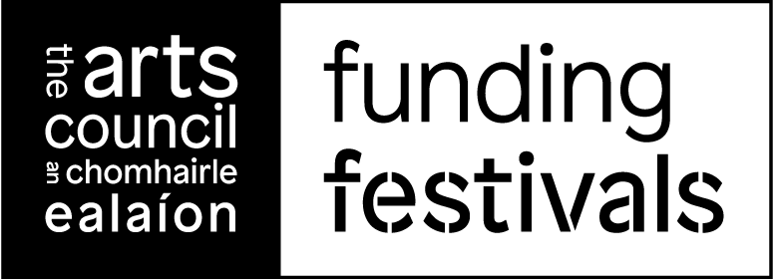

Festival Investment Scheme Round 2024
Revised Plan
If there are any changes to your original application, please list these below. This form should be used to outline any and all amendments and changes made to your 2024 Festival proposal since application.

IMPORTANT NOTE
1. This template must be completed and submitted at least 12 weeks prior to your festival programme commencing. This allows us an opportunity to review and approve any changes you are proposing. We cannot guarantee payment if plans are submitted late.

2. If your festival programme is the same as set out in your original application, please enter ‘no change to application plans’ in boxes A (Plan) and B (Budget)

3. Please complete ALL SECTIONS of the form. (Incomplete forms will be returned)

4. When completed, the Revised Plan must be submitted through online services. We cannot provide payment without receipt of a completed revised plan.

ARN:
Applicant name:
Festival name:
2024 Funding amount offered  (This can be found in your email of offer) | €

Date of original festival (as per application)
Proposed dates of festival

- PLANS
Please provide your any changes to your festival plan below, if there are no changes to your original application please write NO CHANGE:

- BUDGET

Please provide your revised budget for the plan described. (Headline items only)

INCOME | €
Box Office/Activity Income
Other Public Funding
Fundraising
Sponsorship/Fundraising
Sales
In Kind Income
Other Income
TOTAL INCOME
EXPENDITURE | €
Artist Fees
Production/Technical Costs
Salaries/Other fees
Promotion & Publicity
Administration Costs
Travel and Accommodation
Access Costs
In Kind Expenditure
Other Costs
TOTAL EXPENDITURE
BALANCE
ARTS COUNCIL FUNDING OFFER
OUTCOME*

*if you have a surplus or deficit please ensure you explain in the text box below how this deficit/surplus will be dealt with.

- OTHER RELEVANT INFORMATION

Any other relevant information related to your festival plans.

